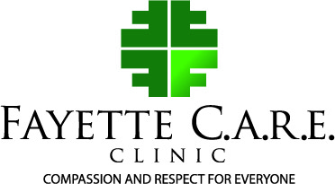

May 2023 Newsletter

Fayette CARE Clinic serves Fayette County and surrounding areas: providing FREE Health Care for uninsured individuals earning 200% below poverty level. C.A.R.E. stands for Compassion And Respect for Everyone.

Fayette CARE Clinic opened on May 1,2005 in Fayetteville Georgia. We were initially open one evening a week and provided only Primary Healthcare. We are now open Monday – Thursday 8:30 am – 4:00 pm weekly providing Primary Healthcare, Vision, Hearing, Telemedicine, Education, Chiropractic, all in-house.

Fayette CARE Clinic has been blessed with the following Partnerships: Piedmont Fayette Hospital, Northside Hospital, Out-Patient Imaging, Ankle & Foot Centers of Georgia, Hudson and Barber Dental, referrals for Mental Health, Outcome Medical, Chiropractic, Panasonic, CMIT, Alpha Internal Medicine, Americares, and Georgia Charitable Network.

Fayette CARE Clinic is a member of the Georgia Charitable Care Network (GCCN) whose mission is “to foster collaborative partnerships to deliver compassionate healthcare to low- income Georgians.” It is also a member of Volunteers in Medicine, a national non-profit organization dedicated to building a network of sustainable, free, primary healthcare clinics for the uninsured in local communities across the country.

Through the care and commitment our dedicated staff, volunteers, and collaborative partnerships with our Healthcare providers, we see progress in improved healthcare and the lifestyles of our patients. Better health, more Opportunities. Through the years most of our patients regain their health and again gain employment and insurance, closing their door with us as it opens for others, New patients enter our doors. Because of grantors and donors, we are able to serve them.

Fayette CARE Clinic is also blessed with the following volunteers: 2 Medical Directors, 4 NP, 1 PA, 1 Retired Pharmacal Rep., 3 Clinical students, 2 translators, 1 Chiropractor, and 4 Medical educators.

Fayette CARE staff works with other community non-profits such as: Real Life Center, Mid-West Food Bank, Fayette Factor, and Grace Church.

We really appreciate all the Fayette CARE Clinic staff, volunteers, and partners. Without them our patients only other choice is the ER.

You can join our team by volunteering or donations for us to continue helping others. Contact us:

Phone: 770.719.4620
Email: info@fayettecareclinic.com
Youtube.com and search Fayette Care Clinic

